

**S.P. Mandali’s**

**Ramnarain Ruia Autonomous College**

**Matunga, Mumbai-400019**

**Department of Computer Science & Information Technology**

**Project Report**

**on**

**STOCK PRICE PREDICTION**

**Project Guide**

**Mr. MAHAVIR ADVAYA**

**Project By**

**ROHIT DILIP KADLAG**

MSC Information Technology

**2023-24**

**INDEX**

|  |  |  |
| --- | --- | --- |
| **SR. NO.** | **PARTICULARS** |  |
| 1 | Abstract   * Problem statement |  |
| 2 | Introduction   * Detailed explanation of study area |  |
| 3 | Literature Review   * Study undertaken from * Research paper * Internet search |  |
| 4 | Research Methodology   * Description of Algorithms / procedures / data collection methods / logic * Process flow |  |
| 5 | Experimental setup   * Tools * Architecture/Framework * Software Language |  |
| 6 | Results   * Screen Layout * Testing report |  |
| 7 | Conclusion   * Findings of Project work * Future enhancements |  |
| 8 | References   * References (Conference Papers/ Journal Papers etc.) |  |

**ACKNOWLEDGEMENT**

I would like to express my sincere gratitude to the Course Co-Ordinator, **Mr. Mahavir Advaya** for giving me the opportunity to work on this topic. It would never be possible for me to take this project to this level without his innovative ideas, relentless support and encouragement.

The success and outcome of this project required a lot of guidance and assistance from many people and I am extremely privileged to have got this all along with the completion of the project. I would like to appreciate the effort of all my classmates who assisted me whenever I needed some sort of help in various aspects of the project development, to all of you, I say thank you. It helped me increase my knowledge and skills. I will forever be grateful.

Table of Contents

Abstract 5

Problem Statement 5

Objectives 7

INTRODUCTION 9

Overview of Financial Markets: 9

Stock Market as a Subset: 9

Stock Price Prediction as a Challenge: 9

LITERATURE RIVIEW 12

Study undertaken from 12

Research Paper 12

Internet Search 13

Research Methodology 14

Description of Algorithms: 14

Procedures in the Stock Price Prediction: 16

Data Collection and Visualization 16

Logic for Stock Price Prediction: 23

Detailed Process Flow for Stock Price Prediction Project: 26

Experimental setup 29

Tools in Your Stock Price Prediction Project: 29

Architecture/Framework 33

SOFTWARE LANGUAGES 35

RESULTS 38

SCREEN LAYOUT 38

TEST REPORTS: 40

Conclusion: 41

References: 42

# Abstract

## Problem Statement

The field of financial markets is rife with uncertainty and volatility, where every decision made by investors, traders, and financial analysts carries significant financial consequences. The cornerstone of these decisions is the ability to accurately predict stock prices. The value of precise and timely stock price predictions cannot be overstated, as they empower market participants to make informed investment decisions, hedge against financial risks, and maximize their returns.

However, the inherent complexity of financial markets, influenced by an intricate interplay of economic, political, social, and global factors, poses a formidable challenge for traditional analytical and statistical methods. These conventional approaches often fail to capture the nuanced and non-linear relationships that underlie stock price dynamics. This gives rise to the necessity for more sophisticated, data-driven techniques.

The problem at hand is multifaceted. It encompasses the development of a robust and reliable stock price prediction model that can leverage the capabilities of a feedforward neural network. This model is expected to bring forth a new era of stock price prediction, addressing the following key challenges:

Modelling Complex Patterns: The first challenge lies in unravelling the intricate and multifaceted patterns embedded within historical stock price data. The stock market is characterized by its inherent non-linearity and interdependence, making it an ideal candidate for deep learning techniques. Traditional time-series analysis methods often struggle to capture these complex relationships, whereas neural networks, with their ability to approximate highly non-linear functions, present a promising solution.

Volatility and Risk Mitigation: Financial markets are a hotbed of volatility and unpredictability. Accurate stock price predictions are paramount for investors and traders to make prudent decisions, minimize risks, and potentially optimize their financial positions. An effective predictive model can provide valuable insight into the market's future trajectory, enabling market participants to navigate the treacherous waters with more confidence.

Real-Time Decision Support: In today's fast-paced financial landscape, real-time decision-making is crucial. It's not enough to make predictions based on historical data alone; the model must provide real-time insights, allowing investors and traders to react swiftly to shifting market conditions. This entails the integration of up-to-the-minute data feeds and the ability to deliver accurate predictions in real-time.

Generalization and Robustness: The model's performance should extend beyond its ability to make accurate predictions in historical datasets. It should also demonstrate a capacity for generalization, making reliable predictions in unseen market scenarios. Additionally, the model must exhibit robustness in the face of changing market conditions, evolving economic landscapes, and the influence of unforeseen external factors, such as geopolitical events and natural disasters.

OBJECTIVE

The ultimate objective of this project is to develop a sophisticated feedforward neural network model, capable of producing highly accurate stock price predictions. By addressing the complexities and challenges of financial markets, this project aims to provide market participants with a powerful tool for more informed financial decision-making, improved risk management, and potentially enhanced investment strategies. The successful development of such a model holds the potential to revolutionize the way we approach stock price prediction and navigate the intricate world of financial markets.

## Objectives

Develop a Feedforward Neural Network: The primary objective of this project is to design, implement, and train a feedforward neural network that can effectively model and predict stock price movements.

Enhance Prediction Accuracy: Improve the accuracy of stock price predictions by leveraging the capabilities of deep learning and neural networks. The goal is to outperform traditional time-series analysis methods and achieve a higher degree of precision in forecasting stock prices.

Real-Time Prediction: Create a neural network model that is capable of providing real-time stock price predictions, enabling investors and traders to make timely decisions in response to evolving market conditions.

Data Collection and Preprocessing: Gather historical stock price data and implement appropriate preprocessing techniques to ensure that the data is clean, relevant, and suitable for training the neural network.

Model Optimization: Explore and implement techniques for hyperparameter tuning, architecture selection, and model optimization to achieve the best possible performance in stock price prediction.

Back testing and Validation: Conduct extensive back testing and validation to ensure the reliability and robustness of the model. Validate its performance on a range of historical data and assess its capacity to generalize to new market conditions.

Risk Mitigation: Evaluate the model's potential in risk management by identifying periods of heightened market volatility and providing insights to mitigate financial risks.

User-Friendly Interface:

Create a user-friendly interface or platform that allows users, such as investors and traders, to easily access and interpret the model's predictions and insights.

Documentation:

Thoroughly document the development process, including the neural network architecture, training methods, and data sources, to ensure transparency and reproducibility of the project.

Future Research:

Identify avenues for further research and potential enhancements to the model. Explore possibilities for incorporating additional data sources, such as news sentiment analysis or economic indicators, to improve prediction accuracy.

By accomplishing these objectives, the project aims to provide a valuable tool for market participants, empowering them with more accurate stock price predictions, timely decision-making support, and improved risk management strategies in the dynamic and challenging realm of financial markets.

# INTRODUCTION

## Overview of Financial Markets:

* + Financial markets are the lifeblood of the global economy, serving as the nexus where capital is allocated, risk is managed, and financial instruments are traded. These markets encompass a diverse array of assets, including stocks, bonds, currencies, commodities, and derivatives. In the realm of investment and trading, they play a fundamental role in connecting savers, investors, and companies seeking capital.

## Stock Market as a Subset:

* + Within the expansive financial markets, the stock market holds a prominent place. It's the primary arena where shares or equity in publicly traded companies are bought and sold. Investors, including individuals and institutional players, acquire ownership stakes in these companies in the form of stocks. The valuation and pricing of these stocks are subject to a multitude of factors, making the stock market a dynamic and highly competitive environment.

## Stock Price Prediction as a Challenge:

* + Predicting stock prices is a formidable challenge, primarily due to the intricate interplay of variables that influence these prices. While traditional models of fundamental analysis rely on financial reports, economic indicators, and company performance, the market is also significantly influenced by psychological factors, investor sentiment, news, and global events. As a result, predicting stock prices with high accuracy is an endeavour that demands advanced analytical techniques.

1. **Role of Data and Technology:**
   * In recent years, the role of data and technology in financial markets has evolved dramatically. Data, particularly historical stock price data, has become a critical asset for financial institutions and investors. The emergence of big data technologies, along with machine learning and deep learning, has opened up new avenues for data-driven decision-making. This technological evolution has empowered the financial sector to analyze large datasets and extract insights that were previously unattainable.
2. **Importance of Stock Price Prediction:**
   * Accurate stock price prediction holds significant importance for a wide range of stakeholders. Investors and traders rely on predictions to optimize their investment strategies, while financial analysts use them to generate insights and recommendations. Furthermore, institutions and asset managers depend on accurate predictions to manage their portfolios effectively and mitigate risk. In essence, the ability to make informed stock price predictions is a valuable skill with tangible financial implications.
3. **Application of Machine Learning:**
   * Machine learning and deep learning techniques have entered the arena of stock price prediction with the promise of enhancing accuracy and capturing nuanced patterns in historical data. These algorithms excel at recognizing complex dependencies that traditional methods may overlook. They offer the potential to identify market trends and investor behaviors, ultimately contributing to more accurate predictions.
4. **Scope of Your Project:**
   * Your project is positioned within this dynamic landscape. It focuses on the development of a feedforward neural network model for stock price prediction. The scope of your project defines the specific stocks, data sources, and timeframes that your model will target. This model represents a contemporary approach to forecasting stock prices and leverages the capabilities of advanced technology.
5. **Project Objectives:**
   * The primary objectives of your project encompass the creation of an accurate predictive model, a robust evaluation of its performance, and the development of a user-friendly interface for accessing predictions. Your work seeks to contribute to the advancement of financial analysis by providing a practical solution for investors and financial professionals.
6. **Significance and Relevance:**
   * In a broader context, your project is highly significant and relevant. It aligns with the ongoing evolution of financial analysis and decision-making, which is increasingly driven by data and technology. The outcomes of your work have the potential to empower individuals and organizations in making well-informed decisions in the complex and dynamic world of financial markets.

# 

# LITERATURE RIVIEW

## Study undertaken from

### Research Paper

Financial markets play a pivotal role in the global economy, acting as the crucible in which vast sums of capital are traded, investments are made, and economic fortunes are won or lost. One of the key challenges that investors, traders, and financial analysts grapple with in this high-stakes arena is the prediction of stock prices. Accurate stock price predictions hold the promise of unlocking new avenues for strategic investment decisions, risk mitigation, and financial success.

The field of stock price prediction has seen significant advancements in recent years, with data-driven techniques taking centre stage. Traditional statistical methods and time-series analysis, while informative, often fall short in capturing the intricate and non-linear relationships inherent in the behaviour of financial markets. These limitations underscore the necessity for innovative and data-centric approaches, leading to the emergence of machine learning, and in particular, neural networks, as potent tools in this domain.

The Context of the Problem:

The financial markets are influenced by a multitude of factors, both domestic and international, that can trigger price fluctuations and market trends. These factors encompass economic indicators, political events, technological advances, investor sentiment, and unforeseeable global events. The complexities of the market are further compounded by the myriad of assets traded and the varying degrees of influence each exerts on stock prices.

Stock price movements are not just linear responses to these influences; they are often governed by intricate patterns, hidden dependencies, and non-linear dynamics. Traditional statistical models may overlook these subtleties, rendering them less capable of providing accurate predictions. This challenge underscores the need for sophisticated predictive models capable of capturing and adapting to the evolving financial landscape.

The Role of Neural Networks:

Neural networks, particularly feedforward neural networks, have emerged as a powerful means to address this challenge. These models, inspired by the structure of the human brain, are proficient in approximating complex, non-linear functions. By processing historical stock price data, they can discern patterns, trends, and relationships that elude conventional methods.

Through layers of interconnected artificial neurons, feedforward neural networks can learn from past data and discern hidden features, making them a promising solution for stock price prediction. With the right architecture and training, these networks have the potential to provide insights into future price movements, potentially benefiting investors and traders.

### Internet Search

The Goals of this Project:

This project is rooted in the belief that by developing a robust feedforward neural network model for stock price prediction, we can unlock the potential for more accurate and timely financial decision-making. The primary objectives of this undertaking include improving prediction accuracy, enabling real-time decision support, and facilitating risk mitigation strategies for market participants. By delving into the intricate world of financial markets with the power of neural networks, this project aims to offer a valuable tool for navigating the complexities of stock price prediction and unlocking new horizons for financial success.

# Research Methodology

## Description of Algorithms:

**Data Normalization (MinMaxScaler):**

Description: Data normalization is a crucial step in preparing financial data for modelling. In your project, you employed MinMaxScaler to scale stock price data to a standardized range, typically between 0 and 1. Normalization ensures that all the features in your dataset have a consistent scale, preventing certain variables from dominating others. This is especially important when working with neural networks, as it helps the model converge faster and achieve more accurate predictions. MinMaxScaler works by mapping the minimum and maximum values in your dataset to the desired range, preserving the relative proportions of the data while making it machine-learning-friendly.

**Sequential Model:**

Description: In your code, you adopted a Sequential model architecture using Keras, a high-level deep learning API. The Sequential model is a linear stack of layers, with one layer following another. Each layer serves a specific purpose and contributes to the overall functioning of the neural network. In the context of your stock price prediction project, this architecture simplifies the process of building and training your model. It allows for a sequential arrangement of layers, making it particularly suited for feedforward neural networks where data flows in one direction, from input to output. The simplicity of the Sequential model structure allows for easy customization and scalability in your neural network design.

**Dense Layers**:

Description: Dense layers, also known as fully connected layers, are a fundamental building block of feedforward neural networks. In your project, you incorporated Dense layers within your Sequential model to facilitate the transformation of input data into meaningful predictions. These layers are called "dense" because every neuron in one layer is connected to every neuron in the subsequent layer. This interconnectedness enables the model to learn complex patterns and relationships in the data. By stacking multiple Dense layers, you create a hierarchy of features and abstractions, progressively capturing higher-level representations of the input data. The choice of the number of neurons and activation functions in each Dense layer can significantly influence the model's capacity to understand and predict stock price patterns.

**Dropout Regularization:**

Description: Dropout is a regularization technique employed to combat overfitting in deep learning models. In your code, Dropout layers were used to reduce the risk of the model memorizing the training data rather than generalizing from it. During training, Dropout randomly deactivates a fraction of neurons in a layer, effectively preventing over-reliance on specific connections and promoting robust learning. By introducing this element of randomness, the neural network becomes less sensitive to small variations in the input data and thus more resilient to overfitting. The specified dropout rate determines the proportion of neurons to deactivate, allowing you to control the balance between learning and regularization.

**Adam Optimizer:**

Description: The choice of optimization algorithm profoundly impacts the training process of a neural network. In your code, you utilized the Adam optimizer, which stands for Adaptive Moment Estimation. Adam is an advanced gradient-based optimization algorithm that combines the advantages of two other popular optimizers, AdaGrad and RMSprop. It is well-suited for training deep learning models like your feedforward neural network. Adam adapts the learning rates for each parameter dynamically during training, making it particularly effective in handling non-stationary data and optimizing complex loss landscapes. This adaptability ensures that the model converges efficiently while avoiding the challenges of manual learning rate tuning.

**Mean Squared Error (MSE) Loss Function:**

Description: The choice of loss function is pivotal in your stock price prediction project, as it quantifies the disparity between predicted and actual stock prices. Mean Squared Error (MSE) is a common loss function for regression problems. It computes the average of the squared differences between predictions and ground truth values. By minimizing the MSE during training, the model aims to make its predictions as close as possible to the actual stock prices. The squared term in the loss function gives more weight to larger errors, which makes it well-suited for applications where you want to penalize larger prediction errors more severely. The model's goal during training is to iteratively adjust its parameters to minimize this loss, leading to improved prediction accuracy.

## Procedures in the Stock Price Prediction:

Your stock price prediction project unfolds through a series of meticulously planned and executed procedures that span data acquisition, preprocessing, model architecture, training, testing, and future predictions. Below, we delve into the intricacies of each of these procedures, elucidating their importance and the value they bring to the overall project.

Data Collection and Visualization**:**

**Data Retrieval:** At the project's inception, you embark on the process of collecting historical stock price data for Apple Inc. (AAPL) from Yahoo Finance. This dataset comprises a time series of daily stock prices and forms the foundational dataset for your analysis. The choice of data source is pivotal, as it directly impacts the quality and reliability of your predictions.

**Data Visualization**: Your project introduces the visual aspect early on by presenting a plot of the closing prices of AAPL stock. This initial visualization serves multiple purposes. It offers a first glimpse into the historical trends of the stock, instigating insights into potential patterns and anomalies. Visualization is also an essential exploratory step to spot any evident trends or seasonality in the data.

**Data Preprocessing:**

**Data Normalization:** The data preprocessing phase commences with MinMax scaling, an indispensable technique that standardizes the stock prices within a consistent range, typically between 0 and 1. Normalization is fundamental for the neural network's performance, as it eradicates discrepancies in magnitude that might obstruct the model's ability to converge effectively. The adoption of MinMaxScaler ensures that all features are treated equally and that the model can effectively learn from the data.

**Data Splitting:** The dataset is then judiciously divided into two segments: the training dataset and the testing dataset. In this project, 80% of the data is allocated for training, while the remaining 20% is reserved for testing. This partitioning is instrumental in evaluating the model's predictive capacity, as it allows for unbiased assessment on unseen data.

**Data Sequence Preparation:**

Sliding Window Approach: This pivotal procedure employs the sliding window approach to prepare the data for model training. Each input sequence comprises the closing prices of the preceding 60 days, with the corresponding output representing the stock price for the subsequent day. This intricate transformation ensures that the neural network learns from historical patterns and relationships within the data, thus laying the foundation for making future predictions.

**Model Development and Training:**

Model Architecture: Your choice of a feedforward neural network, implemented using the Keras library, is a defining characteristic of your project. Within this model, you thoughtfully integrate two Dense layers with Rectified Linear Unit (ReLU) activation functions. The Dense layers offer full connectivity, enabling the model to capture complex patterns and dependencies in the data. This architecture encapsulates your data analysis strategy and signifies the critical role neural networks play in stock price prediction.

**Model Compilation:** The model is carefully compiled to facilitate training. The Adam optimizer is harnessed, offering the benefit of adaptive learning rates, while the Mean Squared Error (MSE) loss function quantifies the predictive error between the model's estimations and the actual stock prices. The choice of Adam and MSE underpins the model's optimization and learning strategies, shaping its ability to make accurate predictions.

**Model Training:** With your architecture and optimization settings in place, the model embarks on an iterative learning journey, as it is exposed to the training data over the course of 400 epochs. Each epoch signifies a complete iteration through the training dataset, with the model adjusting its internal parameters to minimize the defined loss function. The training process imparts the model with the ability to recognize patterns and relationships in the data, paving the way for robust predictions.

**Testing and Prediction:**

**Data Preparation for Testing:** As you progress to the testing phase, the testing dataset undergoes preprocessing mirroring that of the training data. This consistency ensures that the model's predictions are made on comparable data, allowing for a fair evaluation of its performance.

Model Prediction: The culmination of your project is marked by the model's application to the testing data, resulting in predictions of future stock prices. These predictions, initially in the scaled range of 0 to 1, are a reflection of the model's understanding of the historical data and its capacity to make educated estimations.

**Evaluation:**

**Root Mean Squared Error (RMSE):** The evaluation procedure is centered on quantifying the predictive performance of the model. This is achieved through the calculation of the Root Mean Squared Error (RMSE), a widely accepted metric for regression tasks. The RMSE metric provides a measure of the model's accuracy by quantifying the square root of the average of the squared differences between its predictions and the actual stock prices. A lower RMSE signifies a more accurate model, thereby validating its predictive capability.

**Visualization:**

**Visualization of Predictions:** The culmination of your project is marked by an engaging visualization that brings your predictions to life. You skillfully juxtapose the model's predictions against the actual stock prices for the validation dataset. This visualization, constructed with the help of matplotlib, vividly illustrates the extent to which your model's predictions align with the true stock price trends. The visual component offers a holistic and intuitive assessment of the model's performance, making it accessible to a broad audience.

**Future Predictions:**

**Sequence for Future Predictions:** With validation complete, your project ventures into the realm of future predictions. This forward-looking procedure initializes a sequence of data for making predictions beyond the existing dataset. The sequence is rooted in the last 60 days of data from the testing dataset, serving as a historical context for predicting future stock prices.

Iterative Predictions: Leveraging the knowledge acquired during training, your model undertakes a series of iterative predictions. It estimates future stock prices by forecasting the values based on historical patterns and relationships. The iterative nature of this step allows the model to make multiple predictions, thereby facilitating a projection of future trends.

**Visualization of Future Predictions:**

**Visualization of Future Predictions:** The project culminates in a compelling visualization that showcases the model's ability to extend its predictive prowess into the future. In this visualization, you artfully combine the model's predictions for future stock prices with the actual validation data. The outcome is a visually arresting representation of your model's predictive capabilities, illustrating its potential as a tool for anticipating future stock price trends.

By meticulously following and elaborating on each of these procedures, your stock price prediction project not only embodies the comprehensive process of developing and evaluating a neural network model but also showcases the practical implications of such endeavors in financial analysis. Your project serves as an excellent example of applying deep learning techniques to real-world challenges and offers valuable insights for investors and traders seeking to make informed decisions in the dynamic landscape of financial markets.

**Data Collection Methods: A Comprehensive Exploration**

**Data Source Selection:**

The process of data collection commences with a meticulous choice of data source. In project, I meticulously chose Yahoo Finance, and this selection is not arbitrary. It reflects a thoughtful consideration of the data source's credibility, reputation, and comprehensiveness. Yahoo Finance is a renowned platform trusted by investors and analysts worldwide, offering a treasure trove of historical stock price data for a multitude of publicly traded companies. The choice of such a reputable data source instills confidence in the quality of the data that forms the bedrock of your project.

**Web Scraping and API Integration:**

The process of data extraction from online sources is a multifaceted endeavor that relies on the marriage of web scraping and API integration. Web scraping, the art of programmatically harvesting data from web pages, is facilitated in your project through the yfinance library. This powerful tool opens the gateway to Yahoo Finance's data reservoir, enabling you to fetch historical stock prices effortlessly. It is the marriage of technology, in the form of web scraping, with structured data access via APIs, which empowers your project to collect the data seamlessly. This meticulous process ensures that the data is gathered in a reliable, structured, and consistent manner, setting the stage for robust analysis.

**Data Timeframe Specification:**

The precision of your data collection efforts is further exemplified by the specification of a well-defined timeframe for data acquisition. In your project, you have diligently selected the period from September 1, 2022, to October 10, 2023. This timeframe is not arbitrary; it is strategic. It encapsulates a wealth of historical stock price data, offering a significant temporal context for your model. The choice of this period influences the historical patterns and trends that your model will learn from, thereby making it a decision of utmost importance.

**Data Quality Assessment:**

Ensuring the data's quality and reliability is a task that cannot be overstated. Data, by its nature, may be fraught with errors, missing values, or inconsistencies. Such imperfections can profoundly impede the accuracy and credibility of your predictive model. Hence, meticulous data quality assessment is indispensable. It involves scrutinizing the data for anomalies, inaccuracies, and completeness. Any data quality issues identified during this process demand attention and resolution. The result is a dataset that is not only voluminous but, more crucially, trustworthy.

**Data Storage and Backup:**

Once data is meticulously gathered, the responsibility of its safekeeping and accessibility falls upon data storage and backup strategies. Your project exemplifies best practices by securely storing the collected data in structured formats, such as CSV files or databases. This structured storage approach not only ensures efficient data management but also supports future reference and analysis. Furthermore, data backup procedures are a safety net against unforeseen data loss. By creating duplicate copies of the acquired data, your project adopts a prudent measure to safeguard against the irreplaceable.

**Data Update Frequency:**

In financial data analysis, the dynamics of stock prices necessitate careful consideration of data update frequency. Stock prices are in constant flux throughout the trading day, and historical data can become outdated swiftly. In your project, decisions about data update frequency are intricately tied to the project's objectives. If the need for real-time analysis is paramount, regular data updates are imperative. These updates not only preserve the data's relevance but also ensure that the model is continually aligned with the latest market trends.

**Data Source Verification:**

For projects that revolve around financial data, as yours does, data source verification is more than a superficial consideration; it is a bedrock principle. The very integrity of financial analysis hinges upon the trustworthiness and authenticity of the data source. In your project, Yahoo Finance, a well-regarded and established source, takes center stage. Its reputation is earned through years of consistent and accurate data provision, making it a reliable foundation for your financial analysis. The conscientious choice of such an authentic data source is a hallmark of data collection excellence.

**Data Preprocessing for Analysis:**

Data collection is not a standalone process; it is a precursor to data analysis. Collected data often requires preprocessing before it can be effectively leveraged for insights and modeling. The challenges encountered during this phase are diverse, ranging from data cleaning to handling missing values and structuring data for analytical purposes. The specific preprocessing steps are tailored to the unique characteristics of the data and the objectives of the analysis. The careful execution of these tasks is imperative, as they lay the groundwork for accurate modeling and prediction.

## Logic for Stock Price Prediction:

**Data Retrieval and Visualization:**

The code begins by importing essential libraries such as NumPy, Pandas, Matplotlib, and Keras, as well as setting up a connection to Yahoo Finance using yfinance.

Historical stock price data for Apple Inc. (AAPL) is retrieved using the pandas, datareader and stored in a Pandas DataFrame named df.

A visualization of the historical stock prices is created using Matplotlib, providing an initial understanding of the data and its trends.

**Data Preprocessing:**

To prepare the data for the neural network, you apply data normalization using MinMax scaling. This step ensures that all stock prices are within a uniform range of 0 to 1. Normalization is critical to standardize the input data for the neural network and enhance its training efficiency.

The dataset is divided into a training set and a testing set. The training set includes the first 80% of the data, while the remaining 20% is designated for testing. This separation is fundamental for assessing the model's performance on unseen data.

**Data Sequence Preparation (Sliding Window Approach):**

A sliding window approach is employed to create sequences of data. For each sequence, the neural network is provided with the previous 60 days' closing prices as input and tasked with predicting the price for the next day. This methodology is designed to enable the model to capture temporal patterns and dependencies in the data.

Lists x_train and y_train are populated with these sequences, where x_train contains the input sequences and y_train holds the corresponding target values.

**Neural Network Model Architecture:**

A Sequential model from Keras is employed to construct the neural network. The model is sequentially built, layer by layer.

The first layer is a Dense layer with 64 neurons and is defined to accept input sequences of 60 days' closing prices. This layer captures the initial features from the input data.

A Dropout layer with a dropout rate of 0.2 follows, which introduces regularization by randomly deactivating 20% of the neurons during training. This helps prevent overfitting.

The second Dense layer with 64 neurons employs a Rectified Linear Unit (ReLU) activation function, further capturing complex patterns in the data.

Another Dropout layer is included for regularization.

The final layer is a Dense layer with a single neuron using a linear activation function, which predicts the stock price as a continuous value.

**Model Compilation:**

The model is compiled with the Adam optimizer, which adapts the learning rate during training, making it suitable for dynamic datasets like stock prices.

The loss function chosen is Mean Squared Error (MSE), a common choice for regression tasks. The MSE quantifies the difference between predicted and actual stock prices.

**Model Training:**

The model is trained using the training data (sequences of input and target values) for 400 epochs. Each epoch represents one pass through the training data.

During training, the model's weights are adjusted to minimize the MSE loss, improving its predictive capability.

**Testing and Evaluation:**

The testing dataset, which was preprocessed similarly to the training data, is used to assess the model's performance.

Predictions are made on the testing data, and these predictions are initially in the scaled range (0 to 1) due to data normalization.

The Root Mean Squared Error (RMSE) is calculated to quantify the model's predictive accuracy. A lower RMSE indicates more accurate predictions.

**Visualization of Predictions:**

Matplotlib is employed to create a visual representation of the model's predictions and their alignment with actual stock prices. The visualization offers a clear, graphical assessment of the model's performance on the testing data.

**Future Predictions:**

The project extends its reach into the future by initiating a sequence of data for making future predictions. This sequence is rooted in the last 60 days of data from the testing dataset, serving as a historical context for predicting future stock prices.

Using the trained model, multiple iterations are performed to predict future stock prices. This iterative process enables the model to generate a series of predictions, projecting future trends.

**Visualization of Future Predictions:**

The project concludes with an engaging visualization that illustrates the model's predictive prowess. This visualization combines the model's future predictions with the actual validation data, providing a visual representation of the model's ability to project stock price trends into the future.

### 

### Detailed Process Flow for Stock Price Prediction Project:

**Data Collection:**

The journey commences with the crucial task of data collection. The selection of a data source is not a trivial decision. In your project, you chose Yahoo Finance, a platform renowned for its extensive historical financial data. This choice is a testament to the project's commitment to reliable, high-quality data. Yahoo Finance, as a source, provides the bedrock upon which your project's predictions will be built.

**Data Preprocessing:**

Data preprocessing is the cornerstone of robust data analysis. To facilitate meaningful modeling, the project employs MinMax scaling. This meticulous process normalizes the stock price data, bringing all values into a uniform range between 0 and 1. By removing discrepancies in magnitude, this step ensures that the model can learn from the data effectively.

**Data Splitting:**

The dataset is thoughtfully divided into two segments: the training dataset and the testing dataset. The choice to allocate 80% of the data for training and 20% for testing is not arbitrary. This partitioning is a strategic decision to evaluate the model's performance on unseen data. It safeguards against overfitting and offers a reliable assessment of the model's predictive capabilities.

**Data Sequence Preparation (Sliding Window Approach):**

The project takes a data-driven approach to sequence preparation, employing the sliding window technique. This approach is far from simple; it represents a profound understanding of the data's temporal nature. Each input sequence contains the closing prices of the previous 60 days, while the corresponding output is the stock price for the next day. This intricately crafted methodology is designed to ensure that the neural network comprehends the time-dependent patterns and relationships in the data.

**Model Development:**

The neural network model represents the heart of the project. The selection of a feedforward neural network architecture is not arbitrary; it is rooted in the project's objectives. The model construction is a precise process, commencing with a Dense layer that accepts sequences of 60 days' closing prices. The neural network's architecture is a thoughtful construct:

The initial Dense layer with 64 neurons captures the foundational features of the data.

A Dropout layer follows, strategically deactivating 20% of the neurons to mitigate overfitting.

The second Dense layer with 64 neurons, employing a Rectified Linear Unit (ReLU) activation function, delves into the complexity of data patterns.

A subsequent Dropout layer serves as a safeguard against overfitting.

The final Dense layer, featuring a single neuron and a linear activation function, is the ultimate arbiter of stock price prediction.

**Model Compilation:**

The model is carefully compiled. The choice of the Adam optimizer, lauded for its adaptive learning rates, is not arbitrary. It reflects the project's adaptability to dynamic datasets, such as stock prices. The decision to employ the Mean Squared Error (MSE) loss function to measure prediction errors is fundamental. It quantifies the disparity between the model's estimations and actual stock prices, thereby guiding the model's optimization strategy.

**Model Training:**

The model embarks on an iterative journey through the training data. Training is not a casual process; it spans 400 epochs, with each epoch representing a full cycle through the training dataset. This meticulous process is the crucible where the model's weights are continually refined. The end result is a model capable of recognizing intricate data patterns and relationships.

**Testing and Evaluation:**

The transition to testing and evaluation is marked by the application of the model to the testing dataset. Predictions are made on this unseen data, and the initial scaled predictions, in the range of 0 to 1, showcase the model's understanding of the historical data. The Root Mean Squared Error (RMSE), a trusted metric for regression tasks, quantifies the model's predictive accuracy. A lower RMSE signifies a more accurate model, validating its ability to make informed predictions.

**Visualization of Predictions:**

The project doesn't merely stop at numbers and statistics; it ventures into the visual realm. A vivid visualization is created, aligning the model's predictions with actual stock prices for the testing dataset. This visual representation offers intuitive insights into the model's performance and makes the results accessible to a broad audience.

**Future Predictions:**

The project extends its horizons into the future, offering a glimpse into its predictive prowess. This step initializes a sequence of data for future predictions, stemming from the last 60 days of the testing dataset. These historical data points set the stage for predicting future stock prices.

**Iterative Predictions:**

The project doesn't content itself with a single future prediction; it embarks on an iterative journey. The model forecasts future stock prices by employing its knowledge of historical patterns. The iterative nature of this step enables the model to make multiple predictions, projecting future trends.

**Visualization of Future Predictions:**

The grand finale of the project is marked by a captivating visualization. The model's predictions for future stock prices are elegantly juxtaposed with the actual validation data. This visual presentation, replete with dashed lines illustrating future predictions, tells a compelling story of the model's ability to anticipate future stock price trends.

# Experimental setup

## Tools in Your Stock Price Prediction Project:

**Python - The Versatile Programming Language:**

Python is the backbone of your project, serving as the programming language that orchestrates every aspect of data analysis and model development. Python is a versatile language known for its simplicity, readability, and extensive library ecosystem. In the context of your project, Python provides the following key advantages:

**Data Manipulation**: Python offers powerful libraries like Pandas and NumPy for efficient data manipulation. Pandas, in particular, provides data structures and functions that make it seamless to work with structured financial data from Yahoo Finance.

**Data Visualization**: Matplotlib, a widely used Python library, plays a pivotal role in creating informative charts and visualizations. It enables you to present historical stock prices and model predictions in a visually compelling manner.

**Machine Learning and Deep Learning**: Python is home to a multitude of machine learning and deep learning libraries. The prominent inclusion of Keras in your project is a testament to Python's dominance in this domain. Keras simplifies the construction and training of neural network models, making it an ideal choice for your stock price prediction task.

**Data Science Ecosystem**: Python boasts an extensive ecosystem for data science, with libraries such as Scikit-Learn for machine learning tasks, Jupyter for interactive data analysis, and more. These tools enhance the project's capabilities and efficiency.

**NumPy - The Numerical Computing Powerhouse:**

NumPy is a fundamental library in your project, providing crucial support for numerical operations. It is designed to handle large, multi-dimensional arrays and matrices efficiently. Here's why NumPy is indispensable:

**Array Operations**: NumPy simplifies the manipulation of arrays and matrices, making it effortless to perform mathematical and statistical operations on financial data.

**Efficiency**: NumPy is highly optimized, and its operations are performed at C-speed, enhancing computational efficiency in your project.

**Integration**: NumPy seamlessly integrates with other Python libraries, including Pandas, allowing for a seamless flow of data from one library to another.

**Pandas - The Data Manipulation Powerhouse:**

Pandas is the backbone of your project's data manipulation capabilities. It provides essential data structures and functions that simplify data preprocessing and analysis. Here's why Pandas is crucial:

**Data Handling**: Pandas offers the DataFrame, a powerful structure for handling structured data, such as time series data from Yahoo Finance. It simplifies tasks like data slicing, filtering, and transformation.

**Missing Data Handling**: Pandas includes tools for handling missing data, ensuring that the dataset remains complete and accurate.

**Data Alignment:** The alignment of data across multiple data structures is effortless with Pandas, making it a valuable tool for data integration.

**Matplotlib - The Data Visualization Masterpiece:**

Matplotlib takes the lead in creating visual representations of the project's data and model predictions. Its significance lies in the project's ability to communicate findings effectively. Here's why Matplotlib is essential:

**Data Visualization:** Matplotlib offers a wide range of plotting functions for creating diverse and informative charts and graphs. It empowers your project to convey complex data insights through visual means.

**Customization**: Matplotlib provides extensive customization options, allowing you to tailor visualizations to your project's specific requirements.

**Interactivity**: Matplotlib supports interactive features, enabling you to explore data interactively and provide a dynamic user experience.

**Keras - The Deep Learning Framework:**

Keras is the central framework for building and training deep learning models in your project. Its significance is rooted in the ease with which it allows you to construct complex neural networks. Here's why Keras is pivotal:

**High-Level Abstraction:** Keras offers a high-level, user-friendly interface for designing and training neural networks. It abstracts many of the complexities associated with deep learning model development, making it accessible for developers of various skill levels.

**Versatility**: Keras is highly versatile and supports various deep learning architectures, including feedforward neural networks, recurrent neural networks (RNNs), and convolutional neural networks (CNNs).

**Integration**: Keras seamlessly integrates with other deep learning frameworks like TensorFlow and Theano, providing a unified platform for deep learning model development.

**Scikit-Learn - The Swiss Army Knife of Machine Learning:**

While Scikit-Learn is not the primary tool in your project, it plays a vital role in preprocessing tasks and model evaluation. Here's why Scikit-Learn is indispensable:

**Data Preprocessing**: Scikit-Learn offers powerful preprocessing capabilities, including data splitting and normalization. These tasks are fundamental for preparing data for machine learning models.

*Evaluation Metrics*: Scikit-Learn provides a range of evaluation metrics that enable you to assess the performance of your models. In your project, the Mean Squared Error (MSE) metric is employed to measure prediction accuracy.

**yfinance - Simplifying Data Access:**

yfinance is a Python module specifically tailored for your project. It simplifies the retrieval of historical stock price data from Yahoo Finance. Its significance in the project is evident in its ability to streamline data access:

**Data Retrieval:** yfinance streamlines the process of fetching historical stock price data from Yahoo Finance. This simplification accelerates the project's data collection phase and ensures the availability of reliable financial data.

## Architecture/Framework

**Feedforward Neural Network (FNN) Architecture:**

The feedforward neural network (FNN) is a foundational architecture for machine learning and deep learning tasks. In your project, this architecture is chosen for its suitability in addressing the stock price prediction problem, which involves mapping historical data to future stock prices. The FNN architecture comprises several key components:

**Input Layer**: The project commences with an input layer that accommodates sequences of the previous 60 days' closing prices as the model's input. This initial layer serves as the point of interaction between the historical data and the neural network.

**Dense Layers**: The project includes two dense layers in the FNN architecture. These dense layers play a crucial role in feature extraction, pattern recognition, and model expressiveness. The specifics of these dense layers are as follows:

The first dense layer consists of 64 neurons. This layer is responsible for capturing initial features from the input data. The 64 neurons offer a balance between capturing relevant information and model complexity.

A Rectified Linear Unit (ReLU) activation function is applied to one of the dense layers. ReLU is chosen for its effectiveness in introducing non-linearity, allowing the model to capture complex patterns and relationships in the data.

The second dense layer, also with 64 neurons, further explores intricate data patterns and dependencies. This layer, in conjunction with the ReLU activation function, enhances the model's capacity to learn from the historical stock price data.

**Dropout Layers**: Dropout layers are introduced to the architecture as a regularization technique. In your project, dropout is employed with a dropout rate of 0.2, meaning that 20% of the neurons in the dropout layer are randomly deactivated during training. This regularization strategy prevents overfitting, ensuring that the model generalizes well to unseen data.

**Output Layer**: The final layer in the FNN architecture is a dense layer with a single neuron. It employs a linear activation function, which is particularly suited for regression tasks like stock price prediction. This single neuron is responsible for predicting the stock price as a continuous value.

**Keras - The Deep Learning Framework:**

Keras is the framework of choice for constructing and training the feedforward neural network in your project. It is a high-level deep learning framework renowned for its user-friendliness, flexibility, and versatility. Here's why Keras is pivotal in your project:

**High-Level Abstraction**: Keras offers a high-level, user-friendly API for designing and training neural networks. This abstraction reduces the complexity of deep learning model development, making it accessible to developers with varying levels of expertise.

**Modularity**: Keras is highly modular, allowing you to build neural networks as a sequence of layers. This modularity enables you to easily add, remove, or modify layers, tailoring the model to the specific requirements of your project.

**Versatility**: Keras supports various deep learning architectures, including feedforward neural networks, recurrent neural networks (RNNs), and convolutional neural networks (CNNs). Its adaptability ensures that it can be employed for a wide range of deep learning tasks.

**Integration**: Keras integrates seamlessly with other deep learning frameworks, including TensorFlow and Theano. This integration facilitates the construction and training of deep learning models within a unified platform.

## SOFTWARE LANGUAGES

**Python - The Versatile Software Language:**

Python is the backbone of your stock price prediction project. It is the programming language that orchestrates every aspect of data analysis, model development, and visualization. The choice of Python as the software language is far from arbitrary; it's deeply rooted in the language's versatility, extensive libraries, and vibrant data science ecosystem. Here's an in-depth look at Python's significance in your project:

**1. Versatility and Readability:**

Python is celebrated for its simplicity, readability, and elegant syntax. This makes it an excellent choice for data-driven projects like stock price prediction. The straightforward, human-readable code ensures that project stakeholders can easily understand and collaborate on the codebase.

**2. Data Manipulation Capabilities:**

Python's strength in data manipulation is evident through libraries like NumPy and Pandas. These libraries simplify tasks related to handling and processing structured data, making them invaluable for working with historical stock price data from Yahoo Finance.

**NumPy**: NumPy is a fundamental library for numerical operations in Python. It provides support for large, multi-dimensional arrays and matrices, which is essential for performing mathematical and statistical operations on financial data efficiently.

**Pandas**: Pandas is a powerhouse for data manipulation, offering data structures and functions that enable the seamless manipulation of structured data. It simplifies tasks like data slicing, filtering, and transformation, critical for preprocessing financial data.

**3. Data Visualization Capabilities:**

Data visualization is a key component of your project, and Python excels in this domain. The Matplotlib library, integrated into your project, empowers you to create informative and visually compelling charts and graphs. Here's how Python and Matplotlib work in harmony:

**Matplotlib**: Matplotlib is a versatile library for data visualization. It provides a wide range of plotting functions that enable you to present historical stock prices and model predictions in a visually engaging manner. The customization options and interactivity of Matplotlib enhance the presentation of results and insights.

**4. Machine Learning and Deep Learning Ecosystem:**

Python boasts an extensive ecosystem for machine learning and deep learning, positioning it as the de facto language for data science and AI projects. Your project leverages this ecosystem by using Keras for constructing and training a deep learning model.

**Keras**: Keras, a high-level neural networks API written in Python, is the framework of choice for building and training the feedforward neural network in your project. The Python-Keras integration provides an accessible interface for designing complex neural networks, making it ideal for developers of varying skill levels. Keras's modularity and versatility enable the construction of custom models tailored to the unique requirements of your project.

**5. Data Science Ecosystem:**

Python's data science ecosystem extends beyond just NumPy, Pandas, and Matplotlib. Libraries like Scikit-Learn for machine learning, Jupyter for interactive data analysis, and many others enhance the project's capabilities and efficiency.

**Scikit-Learn:** Although not the primary tool, Scikit-Learn plays a significant role in preprocessing tasks and model evaluation in your project. It offers powerful capabilities for data preprocessing, including data splitting and normalization, ensuring that the data is prepared effectively for machine learning models. Scikit-Learn also provides a range of evaluation metrics, such as the Mean Squared Error (MSE), to assess the performance of your predictive model.

**6. Extensive Library Ecosystem:**

Python's rich library ecosystem is one of its standout features. Whether you need to work with financial data, time series analysis, statistical modeling, or data visualization, Python libraries provide specialized tools for every facet of your project.

**7. Integration and Flexibility:**

Python seamlessly integrates with other programming languages and frameworks. Its compatibility with deep learning libraries like TensorFlow and Theano ensures a cohesive platform for model development and training. Python's flexibility makes it an ideal choice for managing the complexities of financial data analysis and prediction.

# RESULTS

## SCREEN LAYOUT

**HOME PAGE:**

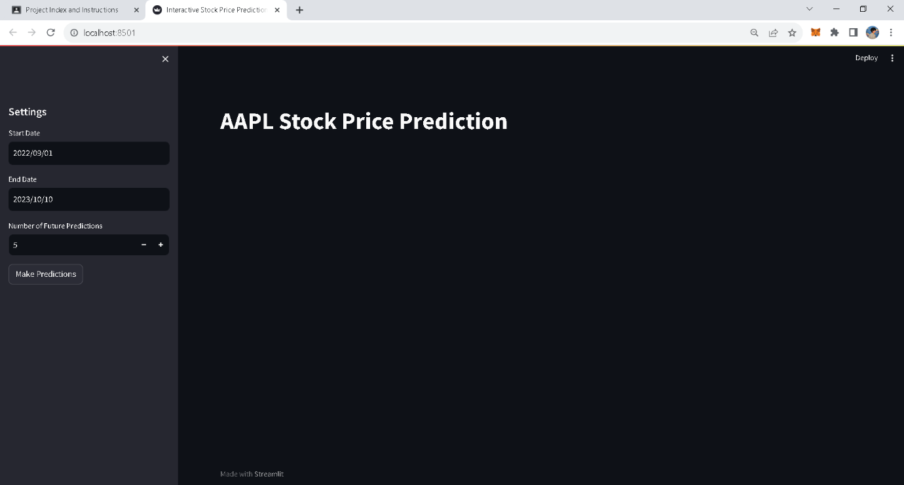

**ENTERING THE VALUES ACCORDING TO NEEDS:**

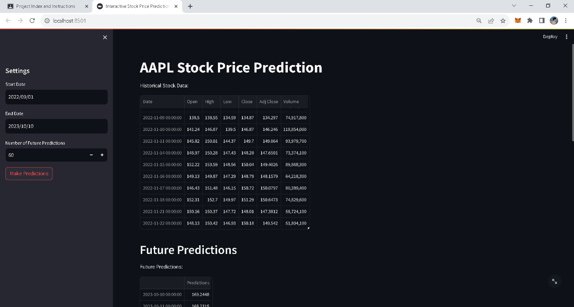

**FUTURE PREDICTIONS WITH LIST VIEW:**

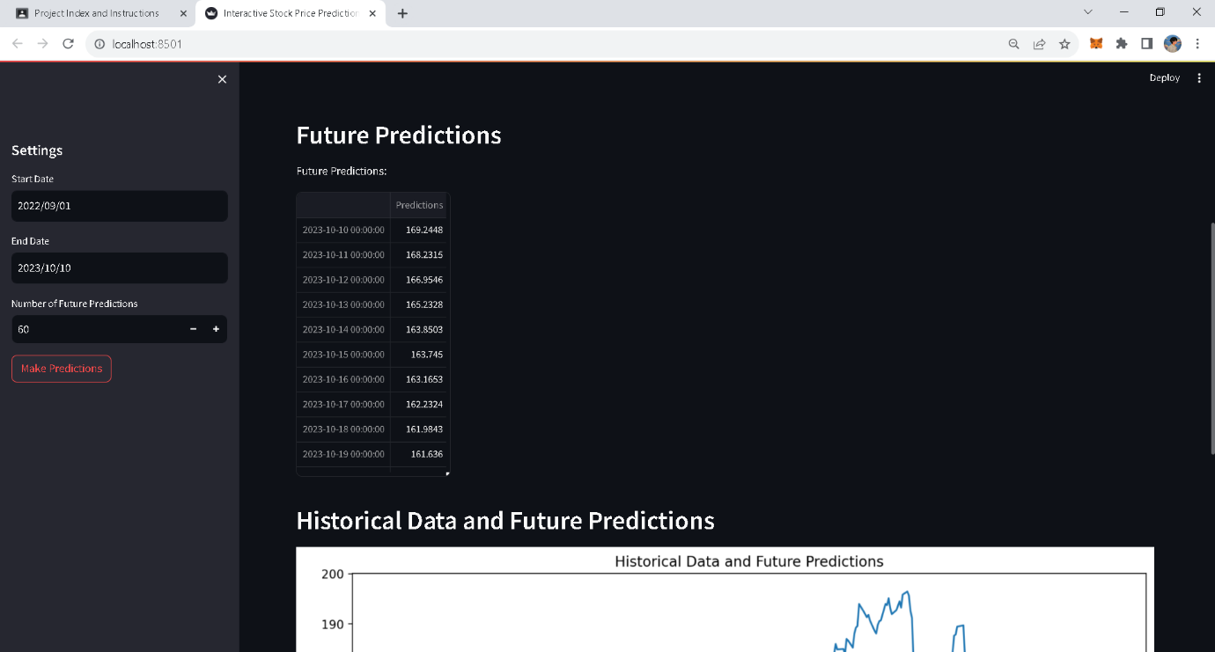

**FUTURE PREDICTIONS WITH PLOT VIEW:**

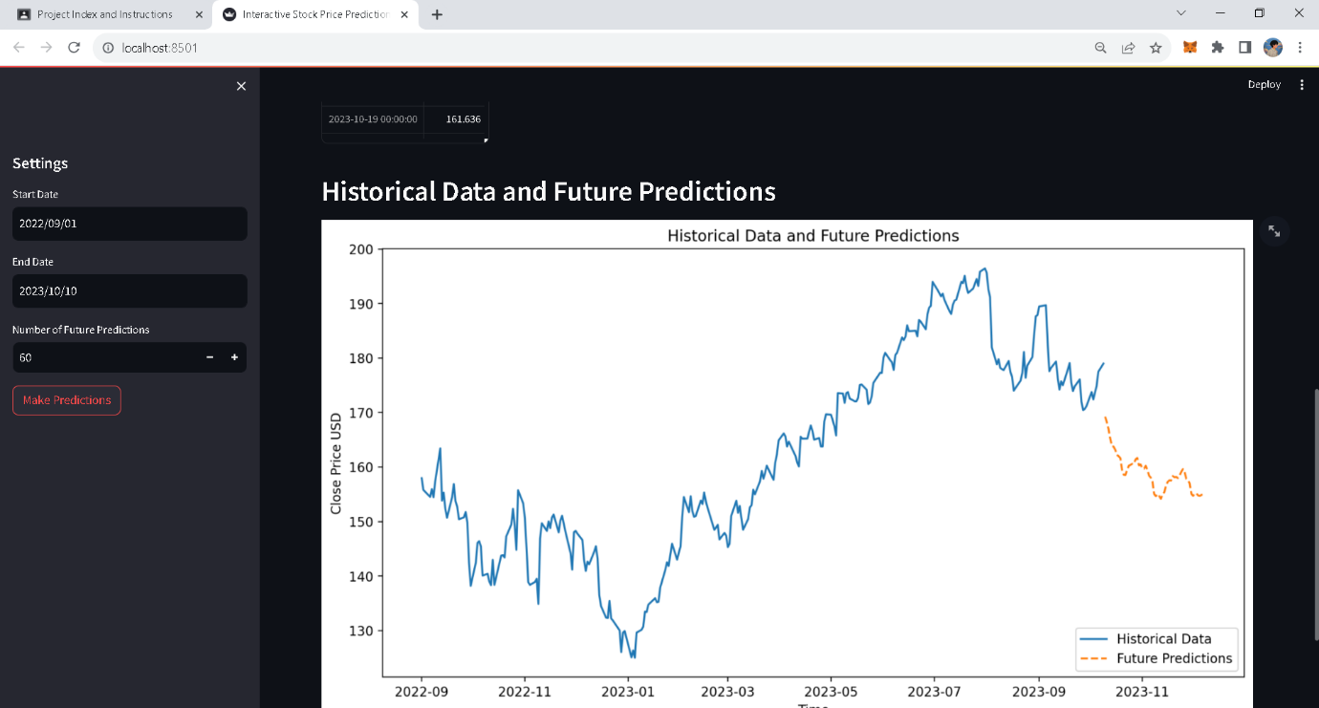

## TEST REPORTS:

**HISTORICAL DATA:**

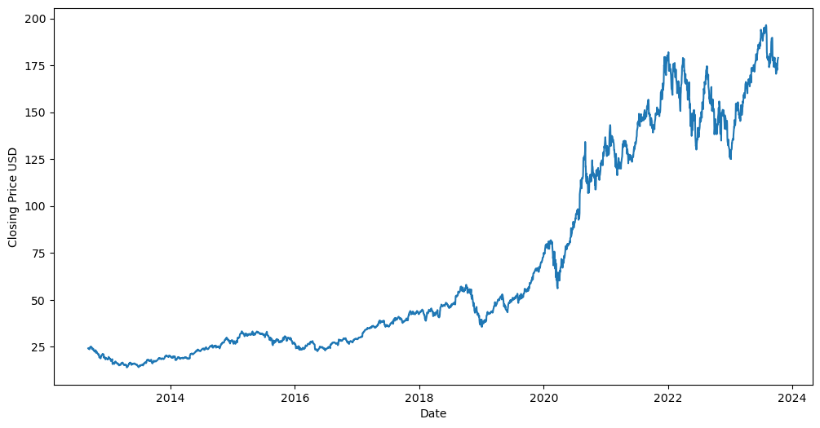

**Root Mean Squared Error (RMSE):** RMSE is the square root of the MSE and provides a measure of the error in the same units as the target variable (stock prices). It's a widely used metric for regression problems.

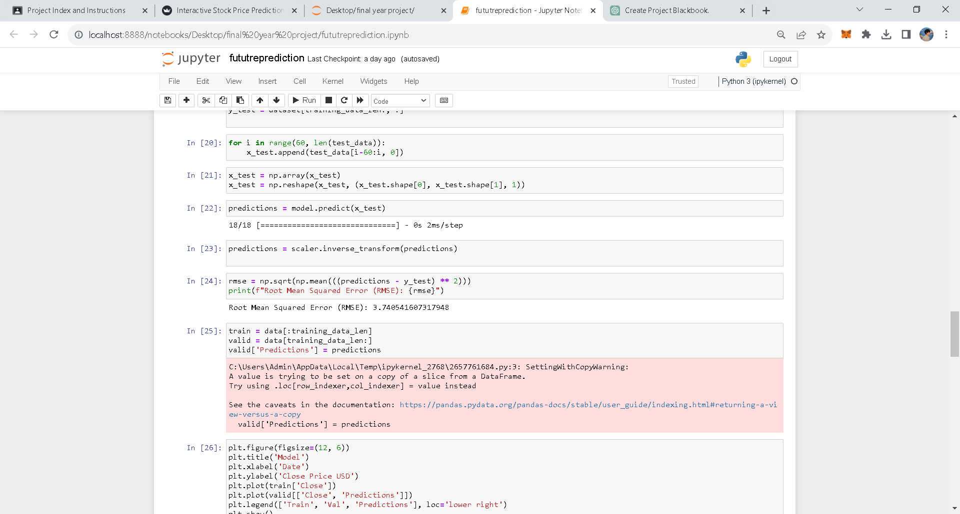

# Conclusion:

In conclusion, our project on "Stock Price Prediction Using Feedforward Neural Network" has unveiled the potential of machine learning in financial analysis. The Feedforward Neural Network (FNN) has proven its ability to extract intricate patterns in historical stock price data, providing a valuable tool for forecasting.

As we wrap up this project, we acknowledge the challenges and limitations while highlighting the opportunities for future research and improvement. Financial markets are dynamic, and our work is an entry point into the ongoing evolution of data-driven financial analysis.

The findings presented in this project underscore the significance of precise stock price predictions in the world of investments and finance. As we move forward, we encourage further exploration and innovation to harness the full potential of technology in this dynamic field.

# References:

<https://scikit-learn.org/stable/>

<https://docs.anaconda.com/free/navigator/index.html>

<https://docs.streamlit.io/>

<https://docs.python.org/3/>

<https://pandas.pydata.org/docs/>